**CURRICULUM VITAE**

* **Name: Hrishikesh Hemant Badve**
* **Date of Birth: 02nd August 1989.**
* **Place of Birth: Pune.**
* **Educational Qualification: M.Com, A.C.A**
* **Practicing Chartered Accountant, Prop. Hrishikesh Badve & Co.**
* **Address: Flat No.157, Bldg. No. 12, Pathik C.H.S.**

**Lokmanyanagar, Pune 411030.**

**Maharashtra, India.**

* **Phone : Res :- 020-24327501**

**Mob:- +918087797657**

**Disciple of : 1. Pt. Vijay Bakshi**

**2. Pt. Gangadharbua Pimpalkhare**

**3.Bhawageet Ratna Shri. Babanrao Nawadikar**

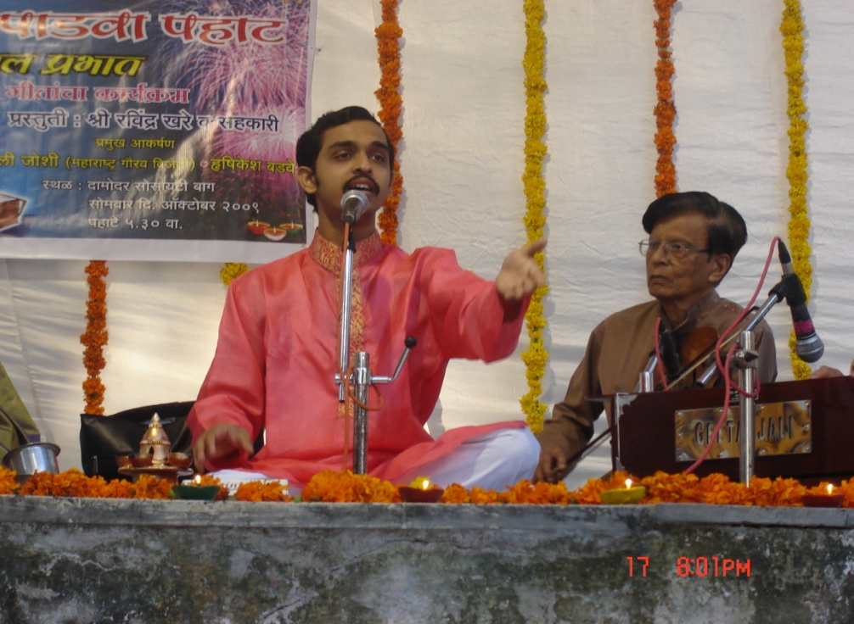

* **The Most Remarkable**

1. ***Empanelled in ‘Panel of Gurus’ in Centre for Performing Arts, Lalit Kala Kendra, University of Pune.***
2. ***National Scholarship for Classical Vocal Music from CCRT (Centre for Cultural Resources & Training), New Delhi.***
3. ***Awarded B High Grade of All India Radio in 2013.***
4. ***Secured First Rank in Akashwani Sangeet Spardha Semi Classical Competitions held by All India Radio in 2006.***
5. ***Secured Second Rank in Akashwani Sangeet Spardha in Classical Vocal Music competitions held by All India Radio in 2006.***
6. ***Various compositions for Kathak like Bandishs, Thumaris, Sargams etc.***
7. ***Performed and Received standing Ovation at First Vishwa Marathi Natya Sammelan, New Jersey, USA in May/June 2010.***
8. ***A Duet for a Marathi Film ‘Bhet’ with Smt. Asha Bhosale.***
9. ***Consistent participation in ‘SaptaSur Maze’ with one of the most leading composers of today Mr. Ashok Patki.***
10. ***Several recordings for All India Radio for broadcasting on Akashwani, Pune***

* **Remarkable Awards**

1. **Late Shri. Madhu Apte Award by Akhil Bharatiya Marathi Natya Parishad.**
2. **Late Abdul Karim Khan Puraskar by Saraswati Sangeet Vidyalaya, Ambejogai.**
3. **Sangeet Ratna Late Shri. Narharbua Patankar Award by Pune Marathi Granthalaya.**
4. **Late Shri UdaySinha Patil Award by Bharat Natya Mandir, Pune.**
5. **Special Jury Award by Maharashtra Manual and Cultural Institution, New Delhi.**
6. **Kala Teertha Puraskar.**
7. **Rotary Club Thane (North) Surshastra Shri Award**
8. **Late Shri. Vasantdada Patil Award by Chandra Surya Rangbhumi.**
9. **Interschool light and classical music competitions Hat Trick of the First number.**
10. **Prashant Damle Fan Foundation- First Prize**
11. **Daily ‘Sakal’ Prize for Semi Classical (Natyasangeet) competition.**

* **Renowned Stage Shows**

1. **Akhil Bharatiya Marathi Natya Sammelan, Karad**
2. **‘SaptaSur Maze’ – A musical concert by renowned composer Mr. Ashok Patki**
3. **Sangeet Katyar Kaljat Ghusali more than 85 shows**
4. **Classical Music Concert at Yashwant Patwardhan Music Academy, Ratnagiri**
5. **Classical Music Concert at Pournima Sangeet Sabha, Chinchwad, Pune.**
6. **Aji Soniyacha Dinu – A concept based individual concert of Abhangas, Bhajans of Saint Dnyaneshwar.**

* **Playback Singing**

1. **Playback singing for various Marathi and Hindi Films.**
2. **Playback singing for serials ‘Nandadeep‘ and ‘Sakha Pandurang’ for ETV Marathi.**
3. **Documentary on Late Mr.Sudhir Phadke**
4. **Playback singing for Marathi film ‘Bhet’ with *Smt. Asha Bhosale.***